**ASSIGNMENT 1 FRONT SHEET**

|  |  |  |  |
| --- | --- | --- | --- |
| **Qualification** | **BTEC Level 5 HND Diploma in Computing** | | |
| **Unit number and title** | Unit 20: Advanced Programming | | |
| **Submission date** |  | **Date Received 1st submission** |  |
| **Re-submission Date** |  | **Date Received 2nd submission** |  |
| **Student Name** |  | **Student ID** |  |
| **Class** |  | **Assessor name** |  |
| **Student declaration**  I certify that the assignment submission is entirely my own work and I fully understand the consequences of plagiarism. I understand that making a false declaration is a form of malpractice. | | | |
|  |  | **Student’s signature** |  |

**Grading grid**

|  |  |  |  |  |  |
| --- | --- | --- | --- | --- | --- |
| P1 | P2 | M1 | M2 | D1 | D2 |
|  |  |  |  |  |  |

|  |  |  |
| --- | --- | --- |
| **❒ Summative Feedback: ❒ Resubmission Feedback:** | | |
| **Grade:** | **Assessor Signature:** | **Date:** |
| **Lecturer Signature:** | | |

1. INTRODUCTION:
2. EXAMINE THE KEY COMPONENTS RELATED TO THE OBJECT-ORIENTATED PROGRAMMING PAREADIGM AND DESIGN A SERIES OF UML CLASS DIAGRAMS:
3. Class and Object:

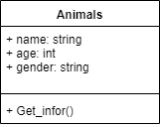

class Animals

{

public string name;

public int age;

public string gender;

public void setname(string Name)

{

name = Name;

}

public void setage(int Age)

{

age = Age;

}

public void setgender(string Gender)

{

gender = Gender;

}

public void Get_infor()

{

Console.WriteLine($"Name: {name} is {age} day -- Gender: {gender}");

}

}

class Program

{

static void Main(string[] args)

{

Animals myanimals = new Animals();

myanimals.setname("black Dog");

myanimals.setage(4);

myanimals.setgender("f");

myanimals.Get_infor();

Console.ReadKey();

}

}

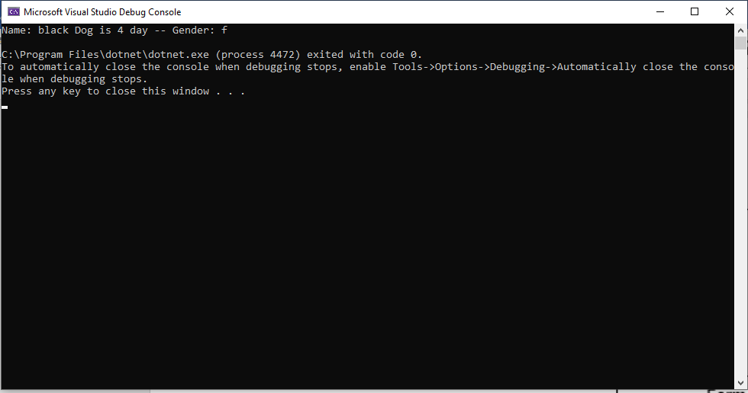

1. Abstraction:

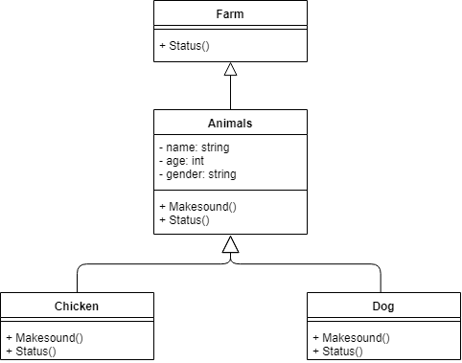

public abstract class Farm

{

public virtual void Status()

{ }

}

public class Animal : Farm

{

private string name;

private int age;

private string gender;

protected Animal(string name, int age, string gender)

{

this.Name = name;

this.Age = age;

this.Gender = gender;

}

public string Name

{

get{return this.name;}

set{this.name = value;}

}

public int Age

{

get{return this.age;}

set{this.age = value;}

}

public string Gender

{

get{return this.gender;}

set{this.gender = value;}

}

public virtual void MakeSound()

{

Console.WriteLine("empty");

}

public override void Status()

{

Console.WriteLine("==Information of Animal==");

}

}

public class Chicken : Animal

{

public Chicken(string name, int age, string gender) : base(name, age, gender)

{

}

public override void MakeSound()

{

Console.WriteLine("O o O o");

}

public override void Status()

{

Console.WriteLine("== Information of Chicken ==");

Console.WriteLine($"Name: {Name}, Age: {Age}, Gender: {Gender}");

Console.WriteLine("=============================");

}

}

public class Dog : Animal

{

public Dog(string name, int age, string gender)

: base(name, age, gender)

{

}

public override void MakeSound()

{

Console.WriteLine("Gau gau Gau gau");

}

public override void Status()

{

Console.WriteLine("== Information of Dog ==");

Console.WriteLine($"Name: {Name}, Age: {Age}, Gender: {Gender}");

Console.WriteLine("=============================");

}

}

class Program

{

static void Main(string[] args)

{

Chicken mychicken = new Chicken("White chicken", 5, "M");

Dog mydog = new Dog("Shiba", 100, "F");

mychicken.Status();

mychicken.MakeSound();

mydog.Status();

mydog.MakeSound();

Console.ReadKey();

}

}

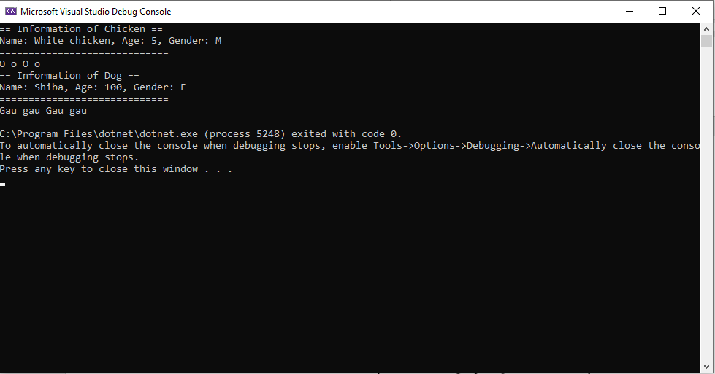

1. Inheritance:

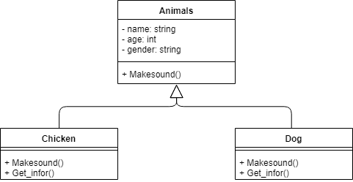

public abstract class Animals

{

private string name;

private int age;

private string gender;

protected Animals(string name, int age, string gender)

{

this.Name = name;

this.Age = age;

this.Gender = gender;

}

public string Name

{

get{return this.name;}

set{this.name = value;}

}

public int Age

{

get{return this.age;}

set{this.age = value;}

}

public string Gender

{

get{return this.gender;}

set{this.gender = value;}

}

public virtual string MakeSound()

{

return string.Empty;

}

}

public class Chicken : Animals

{

public Chicken(string name, int age, string gender) : base(name, age, gender)

{

}

public override string MakeSound()

{

return "O o O o";

}

public void Getinfor()

{

Console.WriteLine($"{Name} is {Age} day");

}

}

public class Dog : Animals

{

public Dog(string name, int age, string gender)

: base(name, age, gender)

{

}

public override string MakeSound()

{

return "BauBau";

}

public void Getinfor()

{

Console.WriteLine($"{Name} is {Age} day");

}

}

class Program

{

static void Main(string[] args)

{

Chicken mychicken = new Chicken("White chicken", 5, "M");

Dog mydog = new Dog("Shiba", 100, "F");

mychicken.Getinfor();

mydog.Getinfor();

Console.ReadKey();

}

}

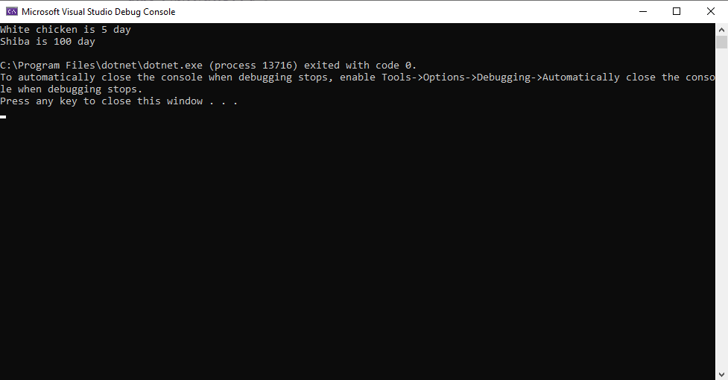

1. Encapsulation:

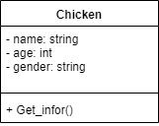

public class Chicken

{

private string name;

private int age;

private string gender;

public string Name

{

get{return this.name;}

set{this.name = value;}

}

public int Age

{

get{return this.age;}

set{this.age = value;}

}

public string Gender

{

get { return this.gender; }

set { this.gender = value; }

}

public void Get_infor()

{

Console.WriteLine($"{Name} is {Age} day - Gender: {Gender}.");

}

}

class Program

{

static void Main(string[] args)

{

Chicken mychicken = new Chicken();

mychicken.Name = "Chicken_Black";

mychicken.Age = 10;

mychicken.Gender = "F";

mychicken.Get_infor();

Console.ReadKey();

}

}

}

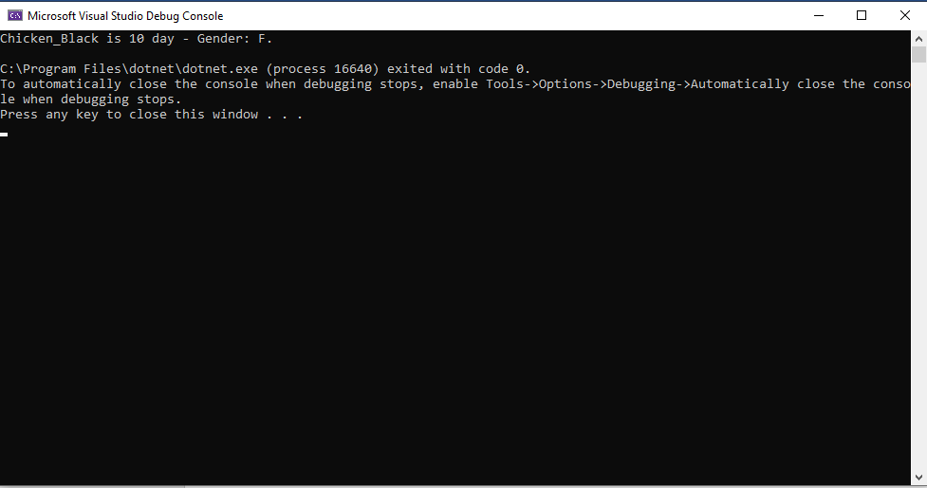

1. Polymorphms:

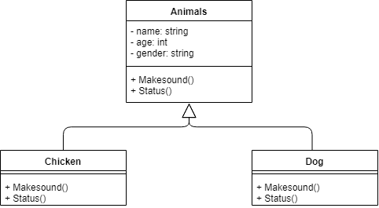

public class Animal

{

private string name;

private int age;

private string gender;

protected Animal(string name, int age, string gender)

{

this.Name = name;

this.Age = age;

this.Gender = gender;

}

public string Name

{

get

{

return this.name;

}

set

{

this.name = value;

}

}

public int Age

{

get

{

return this.age;

}

set

{

this.age = value;

}

}

public string Gender

{

get

{

return this.gender;

}

set

{

this.gender = value;

}

}

public virtual void MakeSound()

{

Console.WriteLine("Sound of animals");

}

public virtual void Status()

{

Console.WriteLine("== Information of Animal ==");

}

}

public class Chicken : Animal

{

public Chicken(string name, int age, string gender) : base(name, age, gender)

{

}

public override void MakeSound()

{

Console.WriteLine("O o O o");

}

public override void Status()

{

Console.WriteLine("== Information of Chicken ==");

Console.WriteLine($"Name: {Name}, Age: {Age}, Gender: {Gender}");

Console.WriteLine("=============================");

}

}

public class Dog : Animal

{

public Dog(string name, int age, string gender)

: base(name, age, gender)

{

}

public override void MakeSound()

{

Console.WriteLine("Gau gau Gau gau");

}

public override void Status()

{

Console.WriteLine("== Information of Dog ==");

Console.WriteLine($"Name: {Name}, Age: {Age}, Gender: {Gender}");

Console.WriteLine("=============================");

}

}

class Program

{

static void Main(string[] args)

{

Chicken mychicken = new Chicken("White chicken", 5, "M");

Dog mydog = new Dog("Shiba", 100, "F");

mychicken.Status();

mychicken.MakeSound();

mydog.Status();

mydog.MakeSound();

Console.ReadKey();

}

}

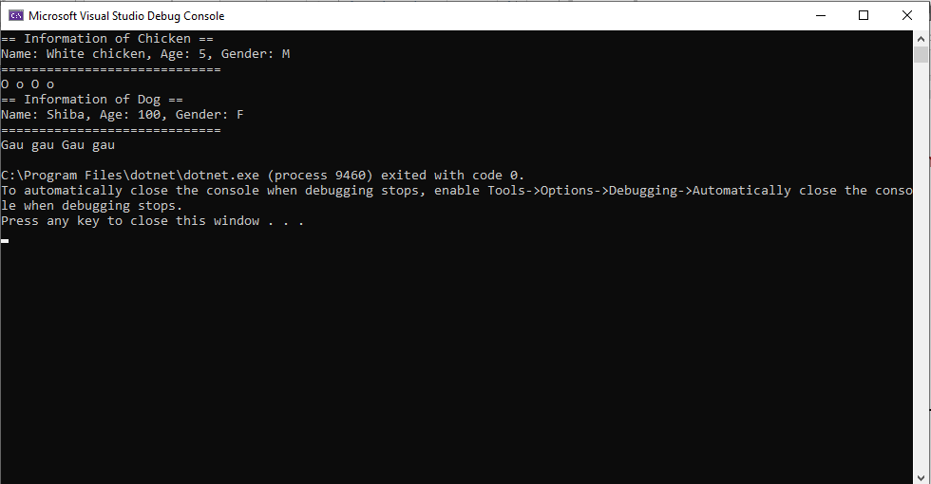

1. CONCLUSION:
2. REFERENCE: